|  |
| --- |
|  |
| **PROJECT REPORT ON COMPLAINT MANAGEMENT SYSTEM USING EJB** |
| **BACHELOR OF TECHNOLOGY (Information Technology Engineering)** |
|  |
| **TG** |
| **4/18/2014** |

|  |
| --- |
|  |

**SUBMITTED BY**

Name of Student(s) University Roll No. (14pt)

Tejas Ghalsasi 6483

Anshul Gadkari 6480

Rohan Kotian 6494

**COMPLAINT MANAGEMENT SYSTEM USING EJB**

# ABSTRACT:

This project demonstrates the use of Stateless Beans and Java in an Enterprise Java Application. The scenario consists of a Back Office of a Moblie Phone company ,KotiSoft. Its website is accessed by the users to Lodge complaints regarding their phones. The website also allows the users to come back and check the status of their complaint. The complaint which the user lodges should be stored in the Database using jdbc. Java Beans are to be used to perform all the operations dealing with business logic.

# INTRODUCTION:

KotiSoft is an India based mobile phone company .Their operations deal with sales and repair of mobiles. KotiSoft follows a trend of releasing flagship models and is kept in high regards in customer service. The website allows customer to send complaints after which a technician is dispatched to the person’s home.

The website also allows the user to check status of their complaint.

# TECHNICAL ASPECTS:

* Front End:
  + HTML
  + CSS
  + JAVASCRIPT
  + JAVA SERVER PAGES
  + SERVLETS
* Backend.
  + JDBC Connection
  + MYSQL DB

**Diagram:**

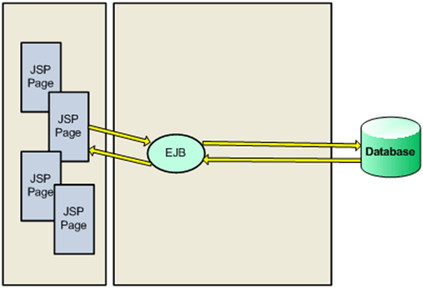

**WORKING:**

* The customer feeds his details in the work that is displayed
* It includes his name,email-id,phone model as compulsory fields.
* When he clicks on Submit, the control is taken to reportthis.java servlet where a Ticket object is created in which his Information is stored.
* Then the servlet calls the EJB, entrybean’s addTicket() method to feed this data into the Database.
* addTicket() method takes the Ticket object and establishes a database connection.
* The database used here is MYSQL DB.
* The values of the ticket are stored .
* Simultaneously the servlet displays a success page on completion.
* The user can check status by entering his email id.
* He is then redirected to Checkstatus servlet.
* The servlet calls the entrybean’s getTicket(String emailid) method and sends the user’s email as input;
* The bean establishes connection to the database and looks up for a record containing same emailid.
* On success it sends a Ticket object back and the servlet displays the information.

**Conclusion:**

Complaint handling service using Enterprise Java Beans and Database is successfully implemented.